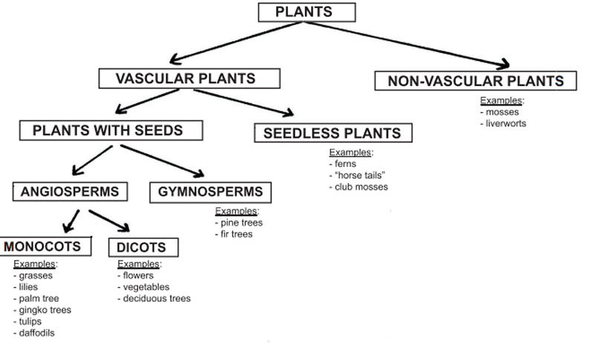

WHAT ARE WE GOING TO STUDY THE WEEK OF August 28 TO SEPTEMBER 1 , 2017
SCIENCE:​
STUDENTS WILL CLASSIFY ORGANISMS INTO GROUPS AND RELATE HOW THEY DETERMINED THE GROUPS WITH HOW AND WHY SCIENTISTS USE CLASSIFICATION.
​
A. DEMONSTRATE HOW ANIMALS ARE SORTED INTO GROUPS (VERTEBRATE AND INVERTEBRATE) AND HOW VERTEBRATES ARE SORTED INTO GROUPS (FISH, AMPHIBIAN, REPTILE, BIRD, AND MAMMAL).
B. DEMONSTRATE HOW PLANTS ARE SORTED INTO GROUPS. ​

ESSENTIAL QUESTIONS:
1. Why do scientists classify things?
2. How do scientists group organisms?
3. How have classification systems changed?
4. What do scientists do when something doesn’t fit in the classification system?
MISCONCEPTIONS:
1. Insects are not animals
2. All animals in the aquatic (water) environment are classified as fish
3. Amphibians and reptiles are part of the same group.
4. Toads and frogs are the same.
5. Snakes are not vertebrates.
6. Human beings are not animals.
7. Mushrooms are plants.
8. Grass is not a plant.
PROPER CONCEPTIONS:
1. Insects are part of the animal kingdom
2. There are aquatic animals that are classified as mammals, invertebrates, etc.
3. Amphibians and reptiles are grouped separately because of their characteristics. Amphibian’s eggs do not have a hard shell like reptile eggs. Amphibians have thin skin that has evolved to absorb water through their skin whereas reptiles have a thick, scaly, dry skin to keep moisture in. Amphibians start out in the water then move to land. Most reptiles live all their life on land. Because of their characteristics, sea turtles are reptiles not fish or amphibians.
4. Warts are caused by human viruses not from the skin of a frog or a toad.
5. Snakes skeletal structure is composed of hundreds of vertebrae with a pair of ribs to go along with each.
6. Human beings are classified as mammals which are part of the animal kingdom.
VOCABULARY AND CONCEPTS TO KNOW: Please print the vocabulary and concepts to know and glue on science journal. Use as a study guide.
Animal – organism that is made up of more than one cell and depends on other organisms for nourishment
Kingdom – the second highest classification into which living organisms are grouped
Species – the most specific classification of living things consisting of closely related organisms capable of interbreeding
Vertebrate – an animal with a backbone or spinal column
Invertebrate –an animal without a backbone or spinal column
Cold-blooded/Ectothermic – having an internal body temperature that changes in accordance with the temperature of the surroundings
Warm-blooded/Endothermic – having a constant warm internal body temperature
Fish – an ectothermic aquatic vertebrate that has gills and fins and is usually covered in scales
Amphibian – an ectothermic, smooth-skinned vertebrate that hatches from an egg laid in water
Reptile – an ectothermic vertebrate that has a covering of scales and reproduces on land
Bird – an endothermic egg-laying vertebrate that has wings and feathers
Mammal – an endothermic vertebrate that has hair and produces milk for its young
Zoologist – a person who studies animals
Biodiversity – the variability of plant and animal life in an environment
​
RESOURCES
studyjams.scholastic.com/studyjams/jams/science/animals/invertebrates.htm
http://studyjams.scholastic.com/studyjams/jams/science/animals/vertebrates.htm​
studyjams.scholastic.com/studyjams/jams/science/animals/arthropods.htm
​www.nationalgeographic.com/animals/invertebrates/
quizlet.com/2594299/5th-grade-chapter-1-classifying-organisms-flash-cards/ THIS IS DUE FRIDAY, SEPTEMBER 1, 2017
www.quia.com/cm/1130.html?AP_rand=1848124035
MATH
multiply multi-digit whole numbers fluently using the standard algorithm (or other strategies demonstrating understanding of multiplication) up to a 3 digit by a 2-digit factor
PRACTICE:
1. A vat of orange juice contains the juice from 843 oranges. If a company has 89 vats, how many oranges would they use to fill them all?
2. A mail sorting machine can sort 774 pieces of mail an hour. If it ran for 77 hour, how many pieces of mail would it have sorted?
3. A farmer has 762 rows of corn. If he can get 84 ears of corn from each row, how many ears of corn would he have total?
4. In NYC each mail truck has 270 pieces of junk mail. If there are 99 mail trucks, how much junk mail do they have total?
RESOURCES:
www.mathantics.com/section/lesson-video/multi-digit-multiplication-pt1
​
​​www.mathantics.com/section/lesson-video/multi-digit-multiplication-pt2
find whole-number quotients of whole numbers with up to four-digit dividends and two-digit divisors, using strategies based on place value, the properties of operations, and/or the relationship between multiplication and division. Illustrate and explain the calculation by using equations or concrete models (e.g., rectangular arrays and/or area models)
PRACTICE:
1. Jerry is trying to earn two hundred nine dollars for some new video games. If he charges forty-seven dollars to mow a lawn, how many lawns will he need to mow to earn the money
2. A company had forty-one employees and ordered nine hundred eighty uniforms for them. If they wanted to give each employee the same number of uniforms, how many more uniforms should they order so they don't have any extra?
3. Victor had eight hundred sixty-one marbles he's putting into bags with twenty-five in each bag. How many marbles will he have in the bag that isn't full?
4. A box of light fixtures cost $forty-three. If you had six hundred dollars and bought as many boxes as you could, how much money would you have left?
IF YOU NEED HELP IN HOW TO DIVIDE TAKE A LOOK AT THESE VIDEOS.
​www.khanacademy.org/math/in-fifth-grade-math/ways-multiply-divide/strategies-multiplication-division/v/partial-quotient-method-of-division-2
​
learnzillion.com/lesson_plans/2651?card=40827
learnzillion.com/lesson_plans/3452?card=48704
​
​learnzillion.com/lesson_plans/3497-using-arrays-and-partial-quotients-to-solve-division-problems?card=49106
www.youtube.com/watch?v=gFEj4ZrLBTs (division decimals)

