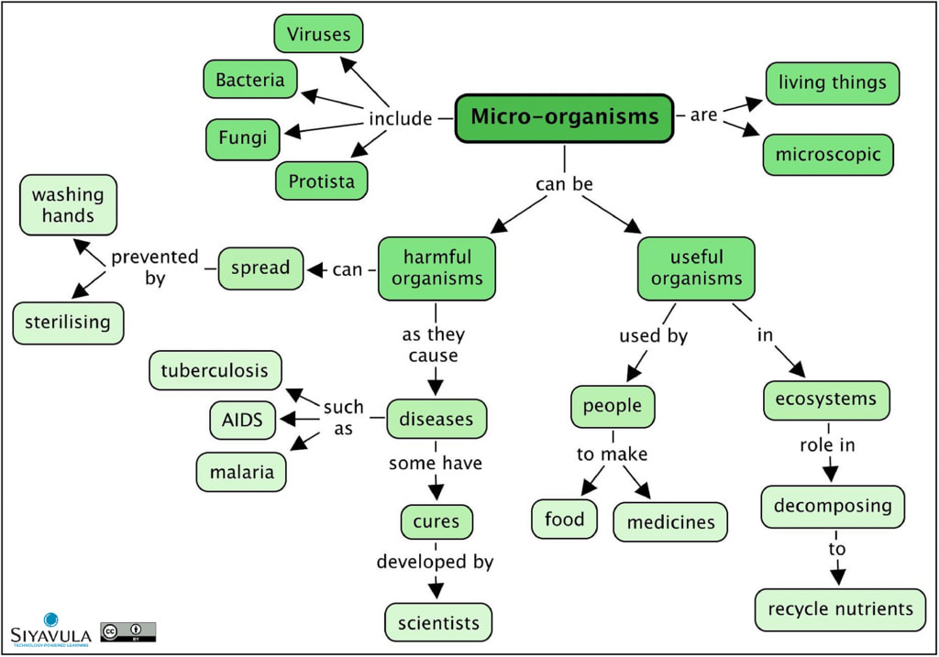

WHAT ARE WE GOING TO STUDY THE WEEK OF OCTOBER 9 TO OCTOBER 13 , 2017

SCIENCE:​

STUDENTS WILL RELATE HOW MICROORGANISMS BENEFIT OR HARM LARGER ORGANISMS.
A. IDENTIFY BENEFICIAL MICROORGANISMS AND EXPLAIN WHY THEY ARE BENEFICIAL.
​B. IDENTIFY HARMFUL MICROORGANISMS AND EXPLAIN WHY THEY ARE HARMFUL.

LEARNING TARGETS:

1. I CAN CONSTRUCT AN ARGUMENT TO SAY WHAT I THINK AND WHY.
2. I CAN SUPPORT A CLAIM AND USE EVIDENCE TO PROVE WHAT I THINK IS TRUE.
3. I KNOW MICROORGANISMS ARE ORGANISMS OR INFECTIOUS AGENTS OF MICROSCOPIC OR SUBMICROSCOPIC SIZE; ADVANTAGEOUS.
4. I KNOW SOME MICROORGANISMS ARE BENEFICIAL WHICH MEANS THEY PROMOTE OR PRODUCE A FAVORABLE RESULT.
5. I KNOW SOME MICROORGANISMS ARE HARMFUL WHICH MEANS THEY CAUSE OR ARE CAPABLE OF CAUSING HARM; INJURIOUS.
6. I KNOW THAT NOT ALL BACTERIA ARE HARMFUL.
7. I KNOW THAT MICROORGANISMS PLAY A ROLE IN THE HEALTH OF ALL ORGANISMS, INCLUDING PLANTS.​

ESSENTIAL QUESTIONS:
​​​WHAT ARE BENEFICIAL MICROORGANISMS?
​BACTERIA, FUNGUS AND PROTISTS ARE ALL EXAMPLES OF HELPFUL MICROORGANISMS.​​​​

How are microorganisms helpful?
Microorganisms help breakdown food in digestion while others (fungi) serve as decomposers to help breakdown decaying plant and animal organisms. Penicillin is an important antibiotic formed from fungal bacteria. Plantlike microorganisms (phytoplankton and algae) found in the ocean provide valuable oxygen to our atmosphere and are important food source to larger organisms. Some bacteria produce methane gas (fuel) during respiration. Other types of bacteria help the environment by converting dangerous chemicals to harmless by-products, ex. oil spills.

How are microorganisms harmful?
Some microorganisms can cause infectious diseases. Certain types of bacteria can cause staph and strep infections while others are known to cause food poisoning. Fungus can cause damage to healthy food crops and cause skin conditions such as ringworm. Microscopic worms can lodge in the intestines of muscles causing serious diseases. Protozoa (animal-like protists) carried by mosquitoes cause malaria, and the Salmonella bacteria lives in chicken and other animals causing food poisoning.

Microorganisms
Microorganisms can be beneficial.
Microorganisms can be harmful.
Microorganisms are too small to be seen with the naked eye.
​Microorganisms are living things. Microorganisms are not plants or animals.

Some microorganisms are harmful, but some are beneficial. Decomposers are microorganisms. Many microorganisms are used in the food-making processes and aid in human digestion. Bacteria are the simplest living group of organisms and inhabit practically all environments. Viruses are generally regarded as non living and therefore are not microbes.
Different diseases are caused by different microorganisms. There are four major types of germs: bacteria, viruses, fungi, and protozoa.

​RESOURCES:

kidshealth.org/en/kids/germs.html#
​
​ed.ted.com/lessons/how-do-germs-spread-and-why-do-they-make-us-sick-yannay-khaikin-and-nicole-mideo
​
MATH: interpret a fraction as division of the numerator by the denominator (a/b = a ÷ b). Solve word problems involving division of whole numbers leading to answers in the form of fractions or mixed numbers, e.g., by using visual fraction models or equations to represent the problem. Example: 3/5 can be interpreted as "3 divided by 5 and as 3 shared by 5”

Knowledge Targets

I know a fraction represents division of the numerator by the denominator.

Reasoning Targets
I can explain how a fraction represents division.
I can explain how the model or equation represents the word problem
Product Targets
I can create contexts to represent problems involving division of whole numbers leading to answers in the form of fractions or mixed numbers.
I can use concrete materials, drawings, and visual fraction models to represent word problems.
I can write equations to represent fraction models and word problems.
VOCABULARY TO KNOW: denominator, fraction, mixed number, numerator
ESSENTIAL QUESTION:
How are fractions related to division?

Having an understanding of equal sharing allows for making connections and interpreting fractions as division of the numerator by the denominator. Using visual models helps make connections and demonstrates understanding of the context.
PROBLEMS OF THE WEEK: PLEASE TURN IN FRIDAY, OCTOBER 13, 2017
1. Roxie is a show dog. Her trainer wants her to have a beautiful and brilliant coat. The veterinarian suggested a special diet for the trainer to follow. Each feeding, Roxie eats 2/3 of a can of wet dog food, 1/8 of a bag of dry dog food, and 3/5 a patty of special meat. The special meat comes in a package of 6 patties. Roxie has two meals a day.
The dog is completely out of food. The trainer goes to the store and buys 24 cans of wet food, 4 bags of dry food and 3 packages of meat.
How many days will the dog be fed before the trainer needs to buy any more food? Which type of dog food will the trainer run out of first? Explain.
How much of the other two types of dog food will be left after the first type of dog food runs out?
The trainer wants to plan better. She goes to the store on the day she ran out of the first type of dog food. She decides to buy enough dog food to last 90 days. Knowing what she already has in the house, how much more of each type of dog food does she need to buy in order to use up all the food in 90 days? Is it possible? Explain.
What is the minimum amount of food the trainer could buy such that the dog would finish all of it after a certain number of meals? Explain.
2. Cindy’s cats often share a carton of cat milk. Sammy always drinks ! 1 3 of the carton, Tommy always drinks ! 5 12 of the carton, and Suzi always drinks ! 1 6 of the carton. What fraction of the carton of cat milk is left over? _________________ Show how you figured it out.
RESOURCES:
www.mathantics.com/section/lesson-video/fractions-are-division

safeshare.tv/submit?url=https%3A%2F%2Fyoutu.be%2FLc_zT7EB51M

SPIRAL REVIEW :

learnzillion.com/resources/72678-use-parentheses-brackets-or-braces-in-numerical-expressions-5-oa-a-1

​virtualnerd.com/common-core/grade-5/5_OA-operations-algebraic-thinking/A/1/simplify-expression-order-operations

​virtualnerd.com/common-core/grade-5/5_OA-operations-algebraic-thinking/A/1/order-operations-definition

​https://www.splashmath.com/common-core-math/fifth-grade/operations-and-algebraic-thinking/1( interactive game-parents can sign up for free.
Task
Marta made an error while finding the product 84.15×10.
In your own words, explain Marta’s misunderstanding. Please explain what she should do to get the correct answer and include the correct answer in your response.

Solution
Marta is mistakenly trying to continue a pattern dealing with multiplying whole numbers by powers of 10: the product will have the same digits as the whole number followed by the same number of 0s as the power of 10. Marta tried to place a 0 after 84.15 in her problem to continue this pattern, but placing a 0 in the thousandths place did not change the value of 84.15. Instead, Marta can shift the decimal one place to the right so that each digit occupies ten times its original place. Her correct answer is 841.5. Another way of finding the product of 84.15 and 10 is to rewrite 84.15 in expanded notation and use the distributive property:
(80+4+0.1+0.05)×10=(80×10)+(4×10)+(0.1×10)+(0.05×10)=800+40+1+0.5=841.5Using expanded notation also highlights that the place value of each digit needs to be multiplied by a factor of 10. It should be noted that the digit 8 in the original expression represented 8 tens, but will be 8 hundreds in our product. In Marta’s solution, the 8 still only represents 8 tens and the magnitude of the number has not changed.

