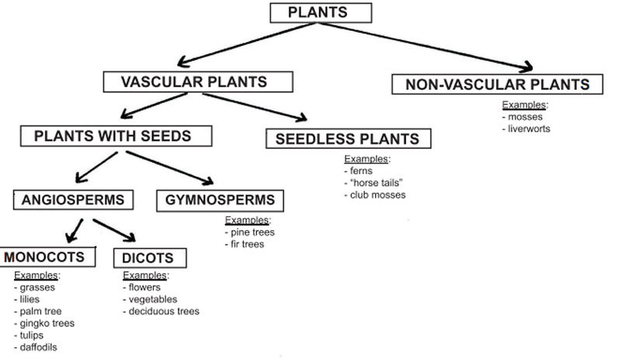

WHAT ARE WE GOING TO STUDY THE WEEK OF SEPTEMBER 5 TO SEPTEMBER 8 , 2017
SCIENCE:​
STUDENTS WILL CLASSIFY ORGANISMS INTO GROUPS AND RELATE HOW THEY DETERMINED THE GROUPS WITH HOW AND WHY SCIENTISTS USE CLASSIFICATION.
​
A. DEMONSTRATE HOW ANIMALS ARE SORTED INTO GROUPS (VERTEBRATE AND INVERTEBRATE) AND HOW VERTEBRATES ARE SORTED INTO GROUPS (FISH, AMPHIBIAN, REPTILE, BIRD, AND MAMMAL).
B. DEMONSTRATE HOW PLANTS ARE SORTED INTO GROUPS. ​
ESSENTIAL QUESTIONS:
1. HOW CAN LIVING THINGS BE SO DIFFERENT YET BE SO ALIKE?
2. HOW ARE PLANTS SIMILAR AND DIFFERENT?
​
Plants are so different from all other kinds of organisms that they get their own kingdom, the KINGDOM PLANTAE. There are 10 divisions,divided into two very basic categories: vascular plants and non-vascular plants (those without a special transport system to carry water and nutrients throughout the plant). The only non-vascular plants are the mosses, hornworts, and liverworts. These plants need to be in very moist surroundings, so they can never grow tall. Ferns and the 'fern allies' (mosses, hornworts, liverworts, whisk ferns, club mosses, quillworts, and horsetails) reproduce with spores (tiny single-celled structures that develop into new plants). Conifers, cycads, gingkoes, gnetophytes, and flowering plants all reproduce with seeds (larger structures that develop after a female egg is fertilized by the male sperm, delivered in pollen).

Among the seed plants, the non-flowering plants (conifers, cycads, gingkoes, and gnetophytes) are also called gymnosperms (`naked seeds') because their seeds are not generally enclosed within fruits. The flowering plants are also called angiosperms (`seeds in a vessel') because their seeds are packaged within fruits. Angiosperms are far and away the most successful contemporary plants, in part because of their ability to lure animals into transporting their pollen and seeds.

So what on earth are algae, fungi, and lichens? These organisms are sometimes studied in herbaria, like plants, but are placed in different kingdoms. Algae, like plants, are photosynthetic and manufacture their own carbohydrates, but they are classified in the KINGDOM PROTISTA. Most plants are relatively large terrestrial organisms, while most algae are microscopic aquatic organisms (although some algaes, like sea lettuce, are multicellular). Fungi are classified in the KINGDOM FUNGI.

Plants can be grouped together using appearance, size, etc. Plants are similar and different in many ways.

MISCONCEPTIONS :
Bushes are baby trees.
Trees are only considered plants when they are small.
Trees, grass, vegetables, weeds are not plants.
PROPER CONCEPTIONS:
A shrub or bush is distinguished from a tree by its multiple stems and lower height, usually less than 6 m tall.
A tree is a large plant. The term generally applies to plants at least 6 m (20 ft) high at maturity and having secondary branches supported on a main stem or stems.
Trees and grasses are plants. A vegetable is the edible part of a plant. A weed in a general sense is a plant. More specifically, the term is
often used to describe plants that grow and reproduce aggressively.

CHLOROPHYLL
Plants are green because they contain a green pigment called chlorophyll. Chlorophyll captures some of the energy in sunlight and uses this to make food. This process is called photosynthesis. Most plants make food this way, but a small number also digest other living things.
​
BIOGRAPHY: CAROLUS LINN`AEUS Swedish, 1707-1778
Naturalist Linnaeus devised the first uniform, scientific way of defining and naming plants and animals. His system is still used as the basis for classification today. The first part of a Linnean name indicates the genus (group). The second part gives the particular species.

Why do scientists use classification in the study of living things?

In the study of living things, scientists use classification to group animals according to their similarities and differences. Since there are many different living things on Earth, scientists developed a classification system that assists in classifying plants and animals in a manageable way.

How do scientists group organisms?

Scientists group organisms based on the features they share. For example, animals have different biological characteristics. These biological characteristics include shape, size, body parts, and color. Scientists use such characteristics to put similar animals into groups.

How are plants broken into groups?

Plants have characteristics that are similar and different too. Plants may be vascular or nonvascular. Vascular plants contain tissue through which water moves up and food moves down. Nonvascular plants have no tissue through which water and food move. Mosses, liverworts, and hornworts are nonvascular plants; ferns and horsetails are vascular plants; pine trees, roses, and maple trees are vascular plants.

THINGS TO DO:

Plants are grouped together by observable features: Observe and sort various fruits and vegetables using your senses: how they taste, how they smell, how they look, how they feel.

Collect different leaves. Sort the leaves into groups according to size, color, shape, etc. Explain how even though the leaves come from a tree, there are different kinds of leaves.

Observe different flowers and plants. Use your senses to compare them. Smell them, taste foods that are plants, compare the colors, count petals, etc.

Group pictures of plants and/or flowers showing their similarities and differences (color, shape, size, appearance, etc).

Even though plants look different, all plants have three things in common: They are made up of more than one cell; they are able to make their own food; and they are green.
Plants are different from animals in two important ways. They cannot move about and most are able to make their own food.
Most plants reproduce using seeds, but there are plants that reproduce using spores (ferns), bulbs (daffodils), and stems (strawberry).
Plants use energy from the sun to make food in a process called photosynthesis. The green substance in a plant’s leaves (chlorophyll) absorbs energy from the sun and uses it to change carbon dioxide and water into food. This homemade plant food is called glucose, which is a type of sugar, and travels through the plant as sap.
Parts of a plant
The stem’s job is to support the plant and transport water and nutrients from the roots to the upper parts of the plant.
The roots’ job is to collect water and minerals for the soil.
The leaves’ job is to make food.
The flower’s job is to make seeds.
Although plants cannot move from place to place, their roots and stems are able to move towards water and light to get the substances needed for photosynthesis.
Most plants begin their life cycle as a seed produced by a flower. Inside each seed is a tiny plant or embryo and enough food for the embryo to use as it grows. The small plant begins to grow when it has enough water, nutrients, and warmth. The seed then sprouts or germinates and begins to grow. When the plant has reached maturity, it is able to produce flowers that in turn produce more seeds.
Pollination is the first step in making seeds. It takes place when pollen from one flower’s stamen reaches another flower’s stigma. When a flower is pollinated and fertilized, its flowers fall off. The ovaries inside the flower grow larger and become fruit.
Because plants cannot move, they need help spreading both their pollen and their seeds. Animals can spread seeds by eating them or when the seeds stick to the animal’s fur.
Some seeds are light and can float in the wind. Others can float on water.
Adaptations
Desert plants such as cacti store water in their waxy stems. Some have huge fibrous roots that soak up dew or rain. Others have long roots that reach deep underground. Their sharp spines help keep animals from eating them.
Water plants have pockets of air in their stem and leaves that help them float. Many absorb nutrients from the water through their leaves. Some have very long roots.
Tropical plants have wide leaves to catch as much sunlight as possible. Some grow as vines to reach sunlight.
Arctic plants grow low to the ground to avoid the wind. They have small leaves that lose little water. Many are covered with tiny hairs that act as insulators.
Deciduous trees do not make food during the winter because there is not enough rain or sunshine.
Conifers have narrow, tough leaves called needles which reduce water los
RESOURCES
www.slideshare.net/polizone/classification-of-plants?from_action=save
​

​
MATH:
Use parentheses, brackets, or braces in numerical expressions, and evaluate expressions with these symbols.
write simple expressions that record calculations with numbers and interpret numerical expressions without evaluating them (e.g., express the calculation "add 8 and 7, then multiply by 2" as 2 x (8 + 7)) and recognize that 3 x (18932 + 921) is three times as large as 18932 + 921, without having to calculate the indicated sum or product)

ESSENTIAL QUESTION:

What symbols are present in numerical expressions? What do they mean?

Mathematical symbols in a numerical expression determine the order of operations that should be performed. These symbols dictate the order that we solve expressions with multiple operations. This ensures that mathematical expressions are solved uniformly.
RESOURCES:
​
mathantics.com/section/lesson-video/order-of-operations

www.khanacademy.org/math/pre-algebra/pre-algebra-arith-prop/pre-algebra-order-of-operations/v/introduction-to-order-of-operations

